One Day International Seminar Dec 10, 2022

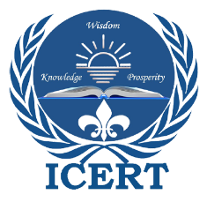
Warm Greetings!
International Council for Education, Research and Training (ICERT) is organizing One Day International Seminar on the occasion of UN World Human Rights Day on

“Dignity, Freedom, and Justice for All”

International Human Rights Day commemorates the adoption of the Universal Declaration of Human Rights (UDHR) by the United Nations General Assembly on December 10, 1948. 'Human rights refer to fundamental rights or freedoms, including people's right to live, health, education, freedom of speech and thoughts, and equal rights.
This day is observed to promote equality, peace, justice, freedom, and the protection of human dignity. Everyone is entitled to rights irrespective of race, color, religion, sex, language, or social status.
On this occasion, ICERT invites academicians, professionals from different disciplines, educators, UG/PG Students, Research Scholars, the general public, and faculty from industries to join this program.
Date: Dec 10, 2022 (Saturday)
Time: 5:30 pm to 7:30 pm (IST)
Participation: Free
A certificate of participation will be issued to all attendees (Registration is mandatory)

Register in advance for this meeting:
https://us06web.zoom.us/meeting/register/tZ0udeyuqT8rE9aq5gHEsLCFOq7mfJ_7sl_T

After registering, you will receive a confirmation email from zoom containing information about joining the meeting, no separate joining link will be sent.
Attendance of the program will be automatically recorded, all candidates who will attend at least 75% of time duration will get the certificate of participation after 10-15 days of the program.
If you have any questions about the seminar, you can contact Ms. Saima, Executive Director of Public Relations at saima@icert.org.in
For more details visit us at

News and Advocacy | ICERT

